T H E 3RD A N N U A L
ALL BUICK CAR SHOW
P R E S E N T E D BY T H E M I L E H I G H B U I C K C L U B
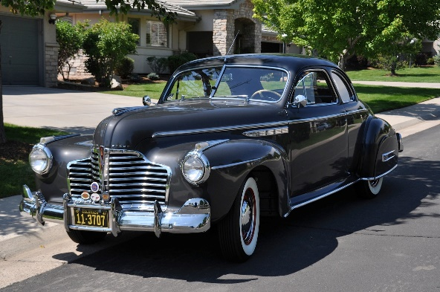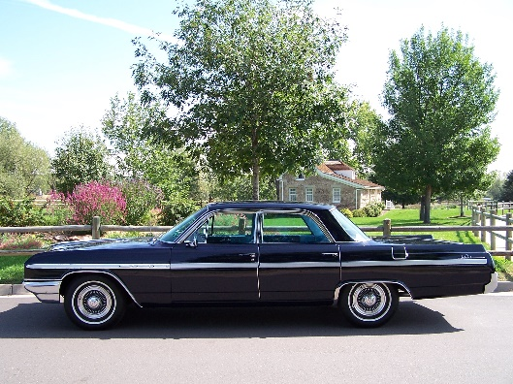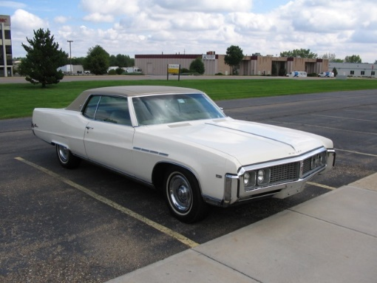
SEPTEMBER 12, 2015
S A T U R D A Y 1 0 AM - 2 PM

AUTONATION BUICK GMC PARK MEADOWS
8101 E. PARKWAY DR., LONE TREE, CO

BRING YOUR FAMILY AND FRIENDS! – FREE HOT DOGS, HAMBURGERS, AND DRINKS – MUSIC
DASH PLAQUES FOR THE FIRST 50 CARS
ALL CAR ENTRIES ELIGIBLE FOR DOOR PRIZE DRAWINGS
POPULAR VOTE AWARD CATEGORIES - AWARDS PRESENTATION AT 2 PM
SHOW CAR PARKING STARTS AT 8 AM – NO REGISTRATION FEE
ALL BUICK OWNERS ARE INVITED TO PARTICIPATE AND SPECTATORS ARE WELCOME
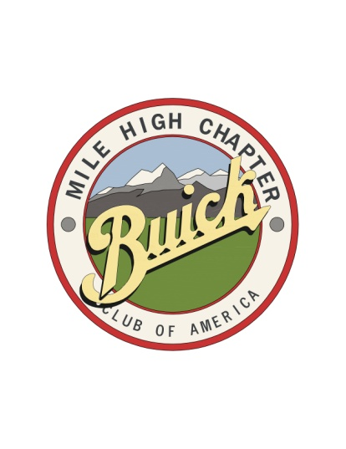
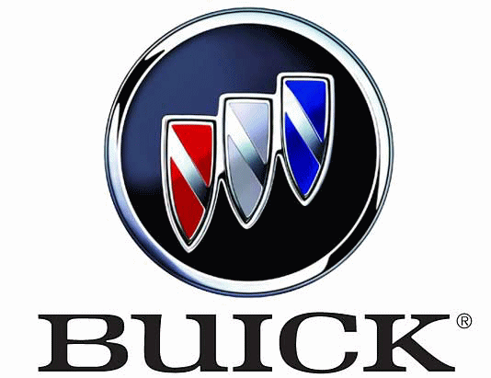
R E G I S T R A T I O N F O R M
3RD ANNUAL ALL BUICK CAR SHOW
CUT AND RETURN TO DAVID WOJAHN
10869 BACKCOUNTRY DRIVE, HIGHLANDS RANCH, CO 80126
FOR INFORMATION CALL: 303-929-7753
OR E-MAIL: DWojahn50@aol.com

NAME ________________________________________________________________________________________________________

ADDRESS ____________________________________________________________________________________________________

CITY ___________________________________ STATE ___________________________ ZIP CODE _________________________

PHONE _______________________________________________ E-MAIL ________________________________________________

YEAR ____________________ MODEL _______________________________ BODY STYLE ________________________________

COLOR ________________________________________________ AWARD CLASS _______________________________________

REGISTRATIONS DUE BY SEPTEMBER 5, 2015

2015 ALL BUICK CAR SHOW

PLEASE INCLUDE YOUR AWARD CLASS ON THE REGISTRATION FORM
- Class A: 1939 & OLDER
- Class B: 1940’s & 1950’s
- Class C: 1960’s
- Class D: 1970’s & 1980’s
- Class E: 1990 AND NEWER
- Class F: MODIFIED
Classes A – E are for restored or unrestored cars in original, stock condition (i.e. not modified or customized).
Class F is for all modified, customized, or otherwise non-stock cars.
Project cars or restoration-in-progress cars are welcome at our show and are encouraged to attend (we want to see how our future award winners are coming along!). Project cars will not be in a separate class this year and should register in one of the above classes.
Please select the award class that fits your car and include the letter designation of that class on the Registration Form (A, B, C, D, E, or F).
Cars will be grouped and parked according to their award class, which will make the voting process easier. Winners will be chosen based on popular vote with a “Best of Class” award given for classes A-F. In addition, the following special recognition awards will be given:
- BEST ENGINE
- PEOPLE’S CHOICE – PRE 1960
- PEOPLE’S CHOICE – POST 1960
- DEALER’S CHOICE
ALL Buick owners are invited to participate in the show, regardless of the year, model, or condition of your Buick. All Buicks are welcome!

