T H E 5TH A N N U A L
ALL BUICK CAR SHOW
P R E S E N T E D BY T H E M I L E H I G H B U I C K C L U B
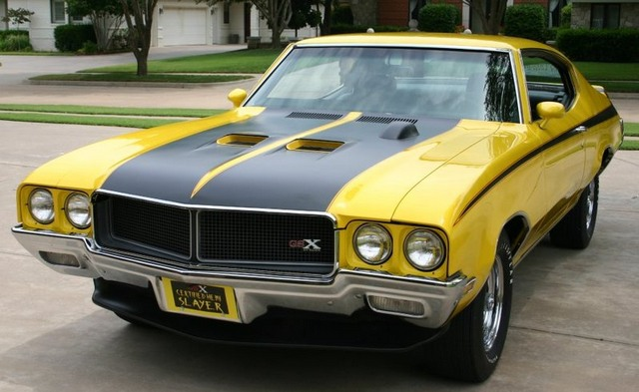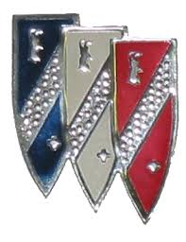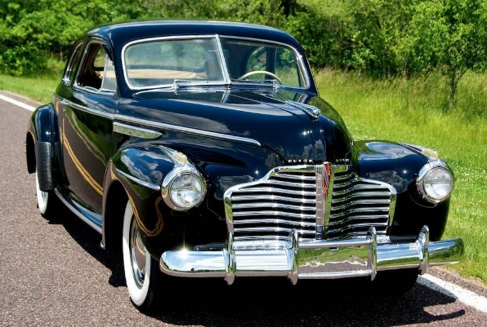
SUNDAY, SEPTEMBER 10, 2017
10:00 AM – 2:00 PM

AUTONATION BUICK GMC PARK MEADOWS
8101 E. PARKWAY DR., LONE TREE, CO

BRING YOUR FAMILY AND FRIENDS! – FREE HOT DOGS, HAMBURGERS, AND DRINKS – MUSIC
ALL CAR ENTRIES ELIGIBLE FOR DOOR PRIZE DRAWINGS
SHOW CAR PARKING STARTS AT 8:00 AM – NO REGISTRATION FEE
POPULAR VOTE AWARD CATEGORIES - AWARDS PRESENTATION AT 2:00 PM
ALL BUICK OWNERS ARE INVITED TO PARTICIPATE AND SPECTATORS ARE WELCOME
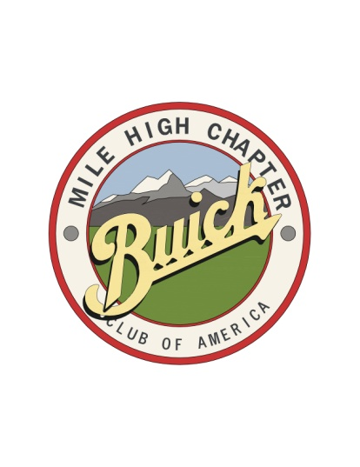
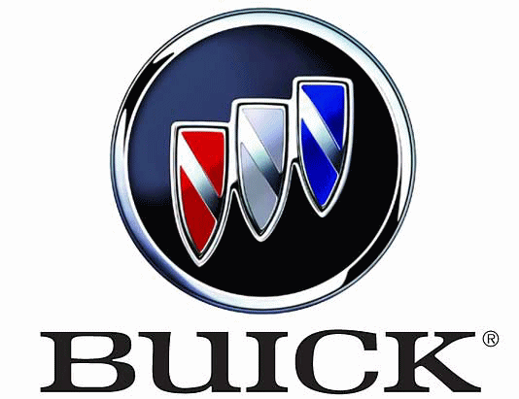
R E G I S T R A T I O N F O R M
5TH ANNUAL ALL BUICK CAR SHOW
CUT AND RETURN TO: DAVID WOJAHN
10869 BACKCOUNTRY DRIVE, HIGHLANDS RANCH, CO 80126
FOR INFORMATION CALL: 303-929-7753
OR E-MAIL: DWojahn50@aol.com

NAME ________________________________________________________________________________________________________

ADDRESS ____________________________________________________________________________________________________

CITY ___________________________________ STATE ___________________________ ZIP CODE _________________________

PHONE _______________________________________________ E-MAIL ________________________________________________

YEAR ____________________ MODEL _______________________________ BODY STYLE ________________________________

AWARD CLASS ______________ IS THIS VEHICLE COVERED BY AUTOMOBILE LIABILITY INSURANCE? (Y / N) ______________

PLEASE SUBMIT CAR SHOW REGISTRATIONS BY WEDNESDAY, SEPTEMBER 6, 2017

2017 ALL BUICK CAR SHOW

PLEASE INCLUDE YOUR AWARD CLASS ON THE REGISTRATION FORM
- Class A: 1939 & OLDER
- Class B: 1940’s
- Class C: 1950’s
- Class D: 1960’s
- Class E: 1970’s & 1980’s
- Class F: 1990 & NEWER
- Class G: Muscle Car
Project cars or “restoration-in-progress” cars are always welcome at our show and should register in one of the award classes listed above.
We have added a Muscle Car Class this year for those bringing a muscle car to the show.
Please select the award class that fits your car and include the letter designation of that class on the Registration Form (A, B, C, D, E, F, or G).
Cars will be grouped and parked according to their award class, which will make the voting process easier. Winners will be chosen based on popular vote with a “Best in Class” award given for classes A-G. In addition, the following special recognition awards will be given:
- BEST ENGINE
- PEOPLE’S CHOICE – PRE 1960
- PEOPLE’S CHOICE – POST 1960
- DEALER’S CHOICE
Registrations will be accepted at the show but pre-registration is requested to help us allocate enough parking space for each award class.
ALL Buick owners are invited to participate in the show, regardless of the year, model, or condition of your Buick. All Buicks are welcome!

